**Haier HRF-628AF6 Side-by-Side**

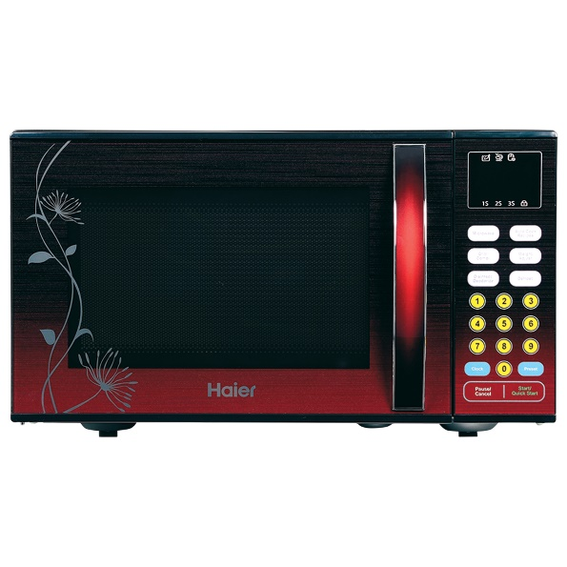

|  |  |
| --- | --- |
| **Capacity(litres):** | 25 |
| **Control System:** | Electronic |
| **Grill:** | Yes |
| **Color:** | Black |
| **Cavity:** | Painted |
| **Built-in Frame:** | No |
| **Net Width x Height x Depth:** | 483 * 420 * 281 |
| **Net Weight:** | 14.5/16 |
| **Nominal Power Microwave:** | 900W |
| **Nominal Power grill:** | 1000W |
| **Microwave Power Levels:** | 6 |
| **Convection function:** | No |
| **Child Safely Lock:** | Yes |